9-1 small portrait layout referenced via alias

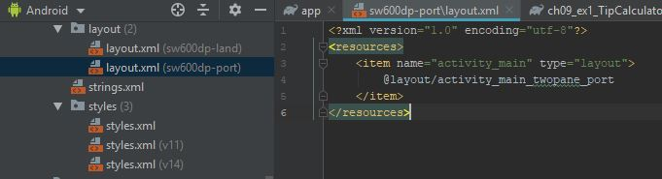

9-1 tablet showing settings fragment

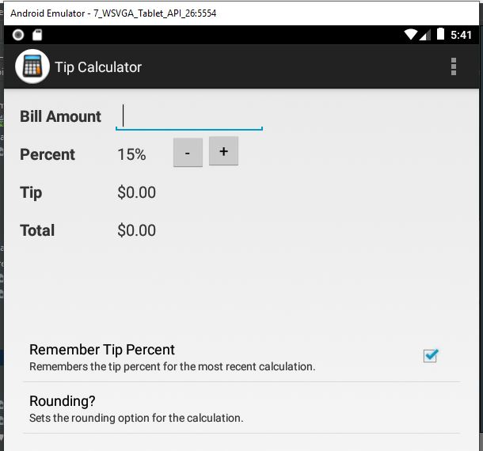

9-1 tablet in landscape

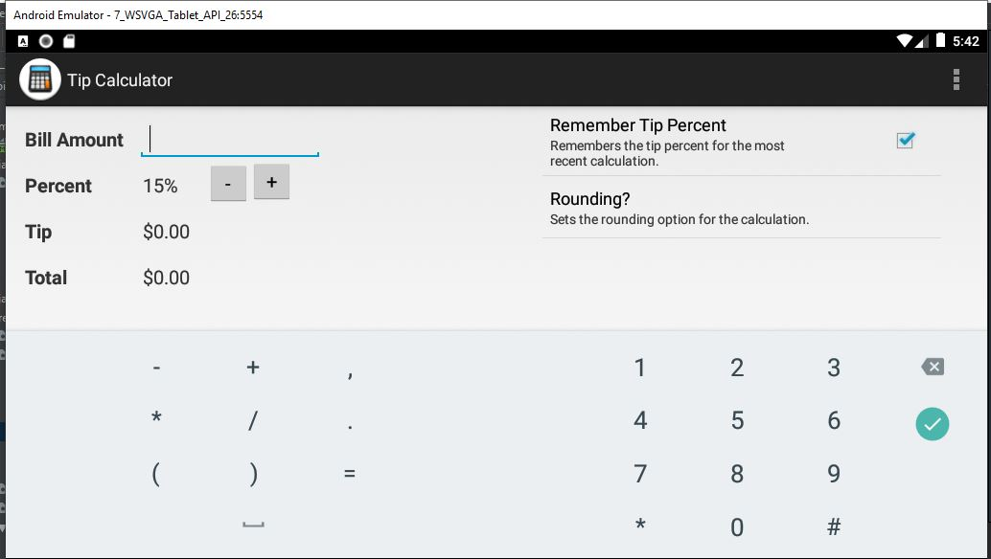

9-2 about fragment

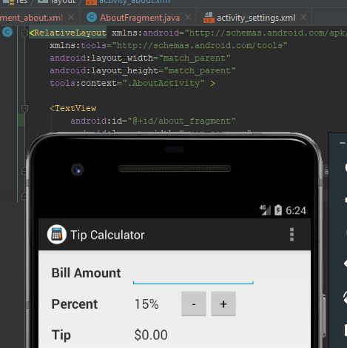

9-2 tablet layout with settings and about fragments

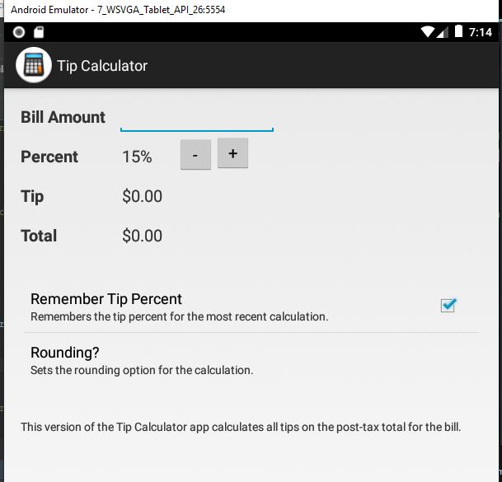

9-3 main activity fragment loaded with fragment manager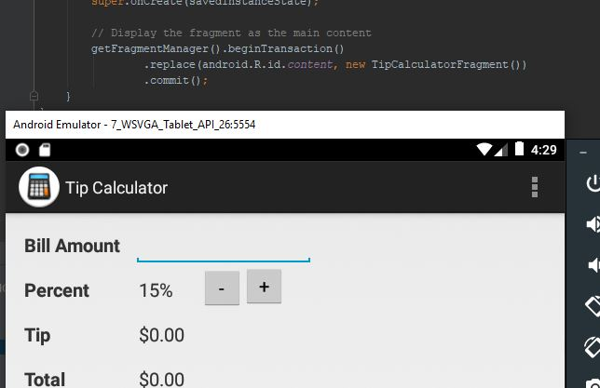

9-3 settings fragment displayed with fragment manager

